**Top Virtual Private Cloud Works Providers**

Each cloud provider offers different models and some price individual resources, such as load balances or storage, separately.

It’s also common for data transfer charges to apply based on volume.

Before selecting a provider consider the requirements of the apps you plan to deploy. Do they require large amounts of memory or CPU fpr example?

**1. Amazon Virtual Private Cloud (Amazon VPC)**

Amazon Virtual Private Cloud enables provision for users to access logically isolated sections of the Amazon Web Services (AWS) cloud. Users can then launch AWS cloud resources in a virtual network.

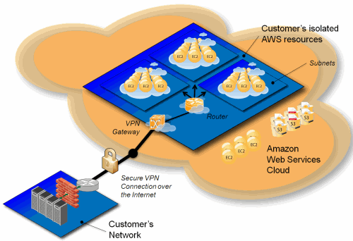[Image source](https://aws.amazon.com/blogs/aws/introducing-amazon-virtual-private-cloud-vpc/)

**Benefits of AWS virtual private cloud include:**

* [**Amazon Private Cloud**](https://aws.amazon.com/vpc/faqs/) offers advanced security features including security groups and network access controls
* AWS Virtual Private Cloud is easy to deploy and manage via the AWS Management Console
* Ability to simplify workload cloud migration with VMware (virtual machines) Cloud on AWS
* Customisable in allowing users to select their own IP address ranges and create subnet as well as configure route tables and network gateways. AWS also accommodates DNS (Domain Name Systems) via a DNS server
* Amazon Private Cloud is charged on an hourly basis

Users retain complete control over their virtual networking environment and functionality, including being able to select their own IP address ranges, create subnets and configure route tables and network gateways. There’s the option to use both IPv4 and iPv6 in a VPC to enable secure easy access to resources and apps.

Amazon VPC networks are easy to configure and create a public-facing subnet for web servers with access to the internet. It’s also possible to put backend systems e.g. databases or **application servers** in private-facing subnets without access to the internet. There are multiple layers of security and network access control lists making it easy to control access to instances in each subnet.

**2. Alibaba Virtual Private Cloud**

Alibaba VPC helps users build isolated network environments using Alibaba Cloud. Users can customise their route table, IP address range, network segment and gateway. It’s also possible to connect VPC and an IDC in order to provide access to hybrid cloud services.

**Advantages of Alibaba Virtual Private Cloud**

* **Securely isolated.** Alibaba VPC creates isolated network environments based on Alibaba Cloud. This affords Layer 2 logical isolation between differing VPC instances.
* **Flexible.** SDN configuration enables users to customise the routeing table and IP address range.
* **Free.** A fully isolated VPC model can be accessed for free on the Alibaba Cloud platform.
* **Robust.** Copes well with disaster recovery.
* **Easy to configure, control and maintain.**
* **Well-documented information** on the internet so users can find self-help information. Users can also take an Alibaba Cloud Certified course to help them plan, configure and manage Alibaba Cloud VPC connection.

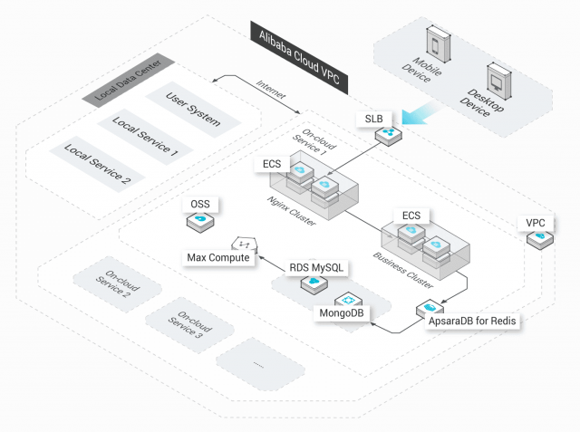

**3. IBM Virtual Private Cloud**

IBM Virtual Private Cloud is ideal for cloud-native workloads; IBM’s experience in building and maintaining cloud architectures are at its foundation. IBM Cloud VPC features a REST-based API that makes it easier to integrate with a user’s legacy applications and toolsets. This also offers multiple connectivity options and integration with all IBM’s Cloud platform capabilities.

Users can create highly available private virtual networks that are secure as well as take advantage of ‘bring your own IP’.

**Advantages of IBM Virtual Private Cloud**

* IBM Virtual Private Cloud is ideal for helping to create hybrid solutions
* Locally isolated VSNs enable enterprises to **[scale infrastructure](https://www.ringcentral.co.uk/gb/en/blog/cloud-alleviate-growing-pains/)** resources for agility
* Covers multiple regions for disaster recovery and resilience
* Pay-as-you-go pricing

You can get set up with [**IBM Virtual Cloud** f](https://www.ibm.com/cloud/vpc)or free and access apps, AI, analytics and other features to build services – or upgrade to access IBM’s full catalogue of products.

**4. Google Virtual Private Cloud (VPC)**

Google Cloud Platform (GCP) is a suite of cloud computing services that run on Google’s internal infrastructure. Google’s infrastructure as a service (IaaS) offers VPC capabilities.

Resources can be provisioned, connected and isolated in a virtual private cloud across all geographies and regions. Users can connect zones without having to add any network complexity since data is encrypted both when travelling and at rest on Google’s global private network.

Google’s identity management policies and security parameters enable users to access Google’s storage, big data and analytics – as well as managed services – privately.

**Benefits of Google VPC**

* Free trial
* Flexibility to scale and control how workloads connect both regionally and globally
* Bring your own IP addresses to Google’s network infrastructure anywhere
* Access VPCs with no need to replicate connectivity or management policies in each region

**How does RingCentral support Virtual Private Cloud?**

For the majority of companies, VPC is the likely option for standard cloud deployment rather than having to build new physical hardware and software – that private clouds require.

VPCs are a ‘best of both worlds’ approach to cloud computing. A virtual private cloud solution is an affordable way to ensure your network infrastructure grows as your business grows.

The virtual private cloud offers companies an opportunity to create **[better experiences for customers](https://www.ringcentral.co.uk/gb/en/blog/cloud-new-black-contact-centre/)**. Another sure-fire way to boost your customer experience (CX) is to adopt a cloud-based telephony system.

RingCentral helps over 350,000 businesses to integrate their communications in the cloud. As a Gartner Magic Quadrant Leader, RingCentral integrates with leading cloud platforms including Amazon AWS so you can be up and running in no time – with employees able to connect with each other and with customers – from any place on any device.